Paradise
Coldplay

Capo 3

Em G D A
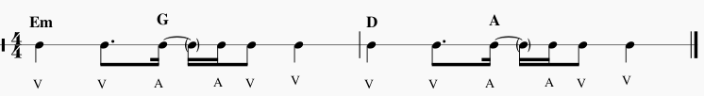

Em G
When she was just a girl
D A
She expected the world
Em G
But it flew away from her reach
D A
So she ran away in her sleep

[Chorus]
Em G
Dreamed of para- para- paradise
D A
Para- para- paradise
Em G
Para- para- paradise
D A
Every time she closed her eyes
Em G D A
Whoa-oh-oh oh-oooh oh-oh-oh X2

Em G
When she was just a girl
D A
She expected the world
Em G
But it flew away from her reach
D A
And the bullets catch in her teeth
Em G
Life goes on It gets so heavy
D A
The wheel breaks the butterfly
Em G
Every tear, a waterfall
G D
In the night, the stormy night
A
She closed her eyes
G D
In the night, the stormy night
A
Away she'd fly.

Chorus]
Em G
And dreamed of para- para- paradise
D A
Para- para- paradise
Em G
Para- para- paradise
D A
Whoa-oh-oh oh-oooh oh-oh-oh
Em G
And dreamed of para- para- paradise
D A
Para- para- paradise
Em G
Para- para- paradise
D A
Whoa-oh-oh oh-oooh oh-oh-oh.

[Bridge]

Em G D A
La la la La
Em G D A
La la la
G D A
So lying underneath those stormy skies.
G D
She said oh-oh-oh-oh-oh-oh.
A
I know the sun must set to rise..

[Chorus]

Em G
This could be para- para- paradise
D A
Para- para- paradise
Em G
This could be para- para- paradise
D A
Whoa-oh-oh oh-oooh oh-oh-oh.

Em G
This could be para- para- paradise
D A
Para- para- paradise
Em G
This could be para- para- paradise
D A
Whoa-oh-oh oh-oooh oh-oh-oh.
Em G
This could be para- para- paradise
D A
Para- para- paradise
Em G
This could be para- para- paradise
D A
Whoa-oh-oh oh-oooh oh-oh-oh.

Em D A
Oo-oo-oo, oo-oo-oo, oo-oo-oo
Em D A
Oo-oo-oo, oo-oo-oo, oo-oo-oo

